HINDQUARTERS : slightly standing towards the back

The standard of the Chart Polski makes reference to a position of the hindquarters " slightly standing towards the back ".

First reflection taken from our " Comments of the standard " published in August, 2000:
" Many of these positions are only attitudes imposed by the handler during the shows, exaggerated attitudes which fast became admitted in the competitions under the pretext of a very debatable aesthetics. For the Chart Polski, as soon as this position exceeds the "light" character, this must be nevertheless considered as a defect ".

I tremble at the very thought of the exaggerated level in which the presentation of Whippets or Afghans in the tenth group is today in the show rings. Not to mention, in the other groups, the Boxers ( group II ) or the German Shepherd dog (group I).
For Boxers, for example, the standard wants simply at the point “Knee (Stifle)” : “When the dog is standing, [the knee] should reach so far forward that it would touch a vertical line from the point of hip to the ground”. For the German Shepherd dog, the standard, at the point “hindquarters” wants : “The hindlegs are placed slightly backwards; seen from the rear, they are parallel to each other. Upper and lower thigh are approximately of equal length and form an angle of about 120° ”… the same angulation at this place asked for the Chart Polski !
In the recent past, the standard of the Afghan Hound required for the body : “the backline appearing PRACTICALLY level from the shoulders to the loin” in English but “un dos légèrement incliné vers l’arrière” in French (body : back “slightly sloping to the rear”). Advantage : so we could not accept “curved” (ensellés) backs. Now, the standard of the Afghan Hound is changed and requires : “Back : level, moderate length, well muscled ; Loin : straight, broad and rather short. ; Croup : falling slightly away to the stern.” … And we see on the rings the handlers posing their Afghans with the hindquarters very far to the rear, “like in the U.S.A.” … Besides, they put both rear legs in a asymmetric way : they want to give more look to the dogs, to let them raise the head and give an idea of their good back propulsion … It has, according to me, especially for effect to break the backline !
And what about the Whippets : at what excesses did we arrive ? Under pretext that he must be “able to stand over a lot of ground “, we put their hindquarters far towards the back. We must say that the text in English doesn’t have the same requirements as the text in French. In French the sentence continues “dog able to stand over a lot of ground … AND (in the same time ! ) gives the impression to have a big back propulsion” , what moderates the first sentence. The poor Whippets so stretched are often obliged to make a small restoring before being able to go round the ring, so artificial their position is and against any idea of "propulsion". If it persisted the slightest doubt, it would be enough to remember that the general aspect of the Whippet requires : “Balanced combination of muscular power and strength with elegance and grace of outline. Built for speed and work. ALL FORMS OF EXAGGERATION SHOULD BE AVOIDED.”

Now that we gave this alarm, let’s come to the second reflection there :

The standard of the Chart Polski in French uses the word “campé”, an unusual word which comes to us from the horses world. It is well defined today : hindquarters slightly “campé”, it means that the vertical lines dropping from the points of buttock reach the ground a little in front of the feet, in passing slightly in front of the metatarsals, instead of following them.
It almost corresponds to a requirement appearing in the new standard of the Borzoi (Standard FCI N°193 / 22. 11. 2006) which, at the point “Hindquarters” says : “When the dog is standing naturally, the vertical line dropping from the ischiatic tuberosity (point of buttocks) must pass in front of the centre of the hock joint and of the metatarsals”
Right !
But the comparison stops there, and it is not the least surprising there : the requirements concerning the line of the back for the Borzoi and the Chart Polish are very different. The back of the Borzoi, has to form a curve with the loin and croup (curve which is more pronounced with the males) ... while, for the Chart Polski, “the topline is straight in the thoracic part” and only “ gently arched in the lumbar region”. (With the females an almost straight topline in the lumbar region is even not a fault).
Who like the sighthounds (Xth group) know that the topline is one of specific characteristics of the morphology of the Borzoi, quite as the structure " higher than long " of Azawakh is an other one.
It is necessary to remember thus here that the structure of the Chart Polski is rather to be compared to that of Saluki, “the Asiatic greyhound who is his ancestor” as the standard 333 exactly says. Regrettably, on the position of the hindquarters, the standard of the Saluki is not really explicit and does not help me a lot :

HINDQUARTERS : Strong, showing galloping and jumping power.
Upper and lower thighs : Well developed.
Stifle : Moderately bent.
Hocks : Well let down.

There is a question left :

Is the “campé” position a natural position ?

For the horse, it is about a natural position but in very particular circumstances:
It is a sign of dominance according the site http://equilove.ch ; a sign of receptivity for the females according the site http://svt.ac-bordeaux.fr, a sign of stomach pains according the site http://www.france-endurance.net/TecVColi.htm ...

And in a show ring ?

At this point of my reflection, I can’t see why, in the canine world, we have to privilege the "campé" position so much. Certainly, the adoption of such a presentation by the handler in shows can draw the attention of the judge and the spectator, this one hoping probably to evoke an " attitude of dominance " … but is it a “natural” attitude for the dog ?
What about the Chart Polski, I am doubtful. The CP can adopt this attitude when standing if we ask him and if we train him in this purpose but, according to me, it is not the attitude which he adopts "naturally".
Some judges in shows, having made the dog run to estimate his movements and his structure, invite the handler to stop the dog without intervening. I rarely saw the Chart Polski adopting a really "campé" position … Sometimes he was very “slightly-campé" and often he was not.
On the contrary, most of the time, the hindquarters are at this moment upright of the line of buttocks and the back presents a light "curve", in contradiction with the standard ! “Curve” that the owner hurries to correct to please the judge and to adopt the "look" appreciated by the current fashion. The position "campé" once adopted by the dog, the handler will have to watch that the neckline is not too straight, like for the English Greyhound for whom this posture is much more convenient.

Conclusions :

I am not sure that the Polish Greyhound emerges victorious from this game of hide-and-seek. The standard of Chart Polski, as all standards, was drafted by referring to a very precise standing position of the dog : for the Chart Polski, the chosen position was the one of a dog with the hindquarters " slightly standing towards the back " (“légèrement campé”). Duly noted.
To present a CP too much “campé” will have for consequence to make him raise the head as the Greyhound does ; to present a CP too little “campé” will have for consequence to make him curve the back as the Borzoi does. The just measure is between these two extremes …
At present, in shows, the handlers and the judges tend to privilege a position hardly stretched by all the sighthounds. Except for the Azawakh. Even the poor small Italian Greyhound (which the body joins nevertheless in a square) does not break it!
The livestock of Chart Polski, the thirteenth sighthound, the "last one" recognized in the family (!), is too weak to impose its law. It will thus be necessary, whatever we think of it, to submit to the whims of the fashion and to continue to present our Chart Polski by stretching them, a position which brings to light them but which seems a little uncomfortable to them. The survival of Chart Polski in the ring of Best in Show depends on that and deserves this small compromise … temporary, we hope.

Philippe Duponcheel

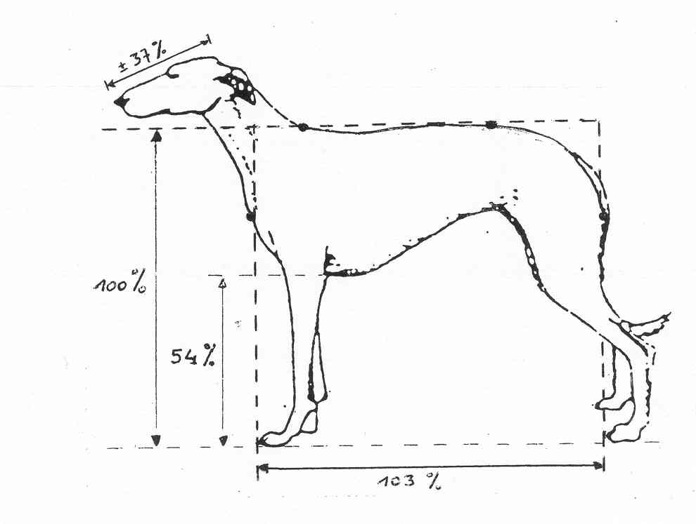

Illustrations :

00 hindquarters slightly standing towards the back : Ch Aïnhoa d’Otchoa (owner M Lintignat)

free position (not “campée”) 01 Ch Marysienka Celerrimus (owners : Françoise
02 Ch Dolores Akacjana and Philippe
03 Ch Lnianka Celerrimus Duponcheel-
Vandenbussche)
comparison 04 Gudelka Arcturus (free position)
05 Gudelka Arcturus (in “show” position)

show 06 Ch Lochynia Celerrimus handler Bartek Gadziomski
07 Ch Elzbieta’s Iskra Roman Mulczynski
08 Ch Marysienka Celerrimus Philippe Duponcheel
09 Ch Lubaska Celerrimus Iza Szmurlo
10 Ch Raptus Celerrimus Malgorzata Szmurlo

Barzoï 11 Youri (owner : Mrs G. Dupret- Polianka Kennel) Philippe Duponcheel

FCI-Standard N° 333 / 01.10.1999 / GB (extract)

POLISH GREYHOUND
(Chart Polski)

GENERAL APPEARANCE : The Polish Greyhound is a dog of great size, powerful, muscular, definitely stronger and less fine in shape than the other short-haired sighthounds (he must not, however, be heavy nor lethargic). In his appearance, he is similar to the Asiatic greyhound who is his ancestor. The strong frame, the short coupled body, the distinctly visible musculature and the powerful jaws show that this dog has been used for hunting in the difficult conditions of the Polish climate. The expressive eyes, with a lively and penetrating look, play an important role in the general aspect of the Polish Greyhound.

IMPORTANT PROPORTION : The proportion of the length of the body in relation to the height at the withers should be 10,2-10,3 : 10.

NECK : Long, muscular, powerful, oval in profile, rising gently from the line of the withers. Head carriage rather high (the Polish Greyhound, at rest, carries the head slightly lower than the Greyhound).

BODY : In the free standing hound, the height at the withers should be equal to the height at the summit of the croup.
Withers : Small, but marked.
Topline : Straight in the thoracic part, gently arched in the lumbar region. In the females an almost straight topline in the lumbar region is not a fault.
Loin : Wide and muscular.
Croup : Oblique, gently slanting, long, muscular and wide; points of hip bones wide apart, (the width between the hip bones represents 12-14 % of the height at the withers.)
Chest : Thoracic cage very spacious and well let down (the ideal is a ribcage reaching the point of the elbow in the sternal region), moderately wide seen from the front; the ribs should be well sprung towards the rear, clearly arched but not barrel-shaped. Long ribs, placed obliquely in relation to the spinal column. Sternum long.
Belly : Tucked up.

HINDQUARTERS : Long, muscular, quite well angulated, slightly standing towards the back and set slightly wide, but definitely less so than in the Greyhound. Seen from behind, the legs should be parallel.
Lower thigh : Long.
Hock : Strong.

FCI-Standard N° 193 / 22. 11. 2006 / GB

BORZOI- RUSSIAN HUNTING SIGHTHOUND
(Russkaya Psovaya Borzaya)

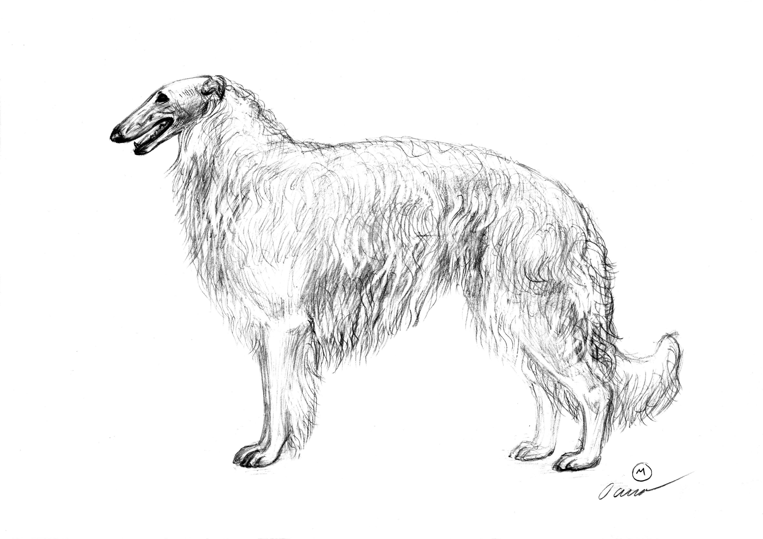

BODY :
Withers : Not marked.
Back : Broad, muscled, elastic, forming with the loin and croup a curve which is more pronounced in the males. The highest point of this curve is situated ahead of the middle of the loin or in the region of the 1st or 2nd lumbar vertebra.
Loin : Long, prominent, muscled, moderately broad.
Croup : Long, broad, slightly sloping. The width of the croup measured between the two hip bones (iliac crests) must not be less than 8 cm.

HINDQUARTERS : Seen from behind : straight, parallel, set slightly wider than the forequarters. When the dog is standing naturallly, the vertical line dropping from the ischiatic tuberosity (point of buttocks) must pass in front of the centre of the hock joint and of the metatarsals.
Upper thigh : Well muscled, long, placed obliquely.

FCI-Standard N° 162 / 14. 05. 2007/ GB

WHIPPET

GENERAL APPEARANCE : Balanced combination of muscular power and strength with elegance and grace of outline. Built for speed and work. All forms of exaggeration should be avoided.

BODY :
Topline: Showing a graceful arch over loin but the dog is not humped.
Back : Broad, well muscled, firm, somewhat long.
Loin : Giving impression of strength and power.

HINDQUARTERS : Strong. Dog able to stand over a lot of ground.
Thighs : Broad across.
Stifles : Well bent.
Second thighs : Well developed.
Hocks : Well let down.

Standard FCI N° 162 / 14. 05. 2007 / F

WHIPPET

Aspect général : Equilibre de la puissance musculaire et de la force alliées à l’élégance et la grâce des lignes. Construit pour la vitesse et le travail. Toute forme d’exagération doit être évitée.
Ligne du dessus : Présente une gracieuse arcure au niveau du rein mais le chien n’est pas bossu.
Dos : Large, bien musclé, ferme, plutôt long.
Rein : Donne une impression de force et de puissance.
Membres postérieurs : Forts. Le chien est capable de couvrir beaucoup de terrain en station debout et donne l’impression d’avoir une grande puissance de propulsion

Remarque : la dernière phrase citée est absente de la version du standard en anglais.

